AIM: Learning of various environment which can be used for python programming.
Solution:
- Jupyter Notebook
The Jupyter Notebook is an incredibly powerful tool for interactively developing and presenting data science projects. A notebook integrates code and its output into a single document that combines visualizations, narrative text, mathematical equations, and other rich media. The intuitive workflow promotes iterative and rapid development, making notebooks an increasingly popular choice at the heart of contemporary data science, analysis, and increasingly science at large. Best of all, as part of the open source Project Jupyter, they are completely free.

Fig 1: Jupyter Icon

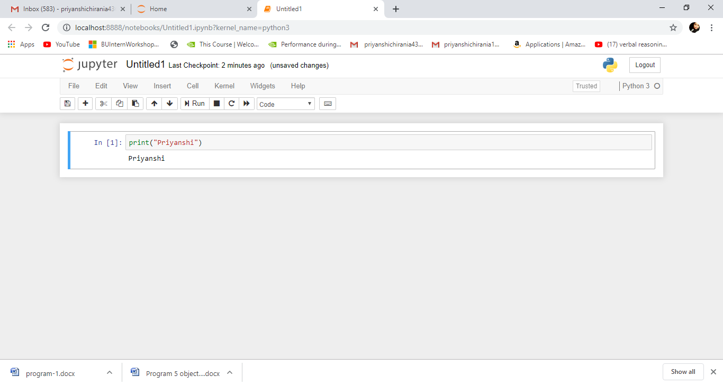
Fig 2: Code Window of Jupyter Notebook

- Spyder
Spyder, the Scientific Python Development Environment, is a free integrated development environment (IDE) that is included with Anaconda. It includes editing, interactive testing, debugging and introspection features.
It is an open source cross-platform integrated development environment (IDE) for scientific
programming in the Python language. Spyder integrates with a number of prominent packages in the scientific Python stack, including NumPy, SciPy, Matplotlib, pandas, IPython, SymPy and Cython, as well as other open source software. It is released under the MIT license.
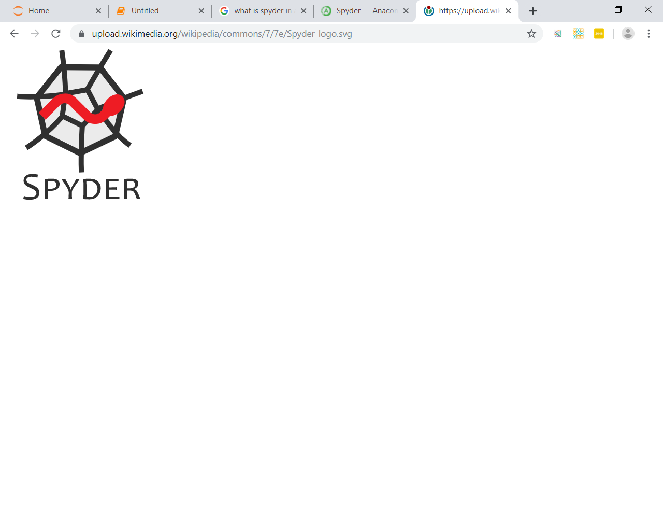
Fig 3: Spyder Icon

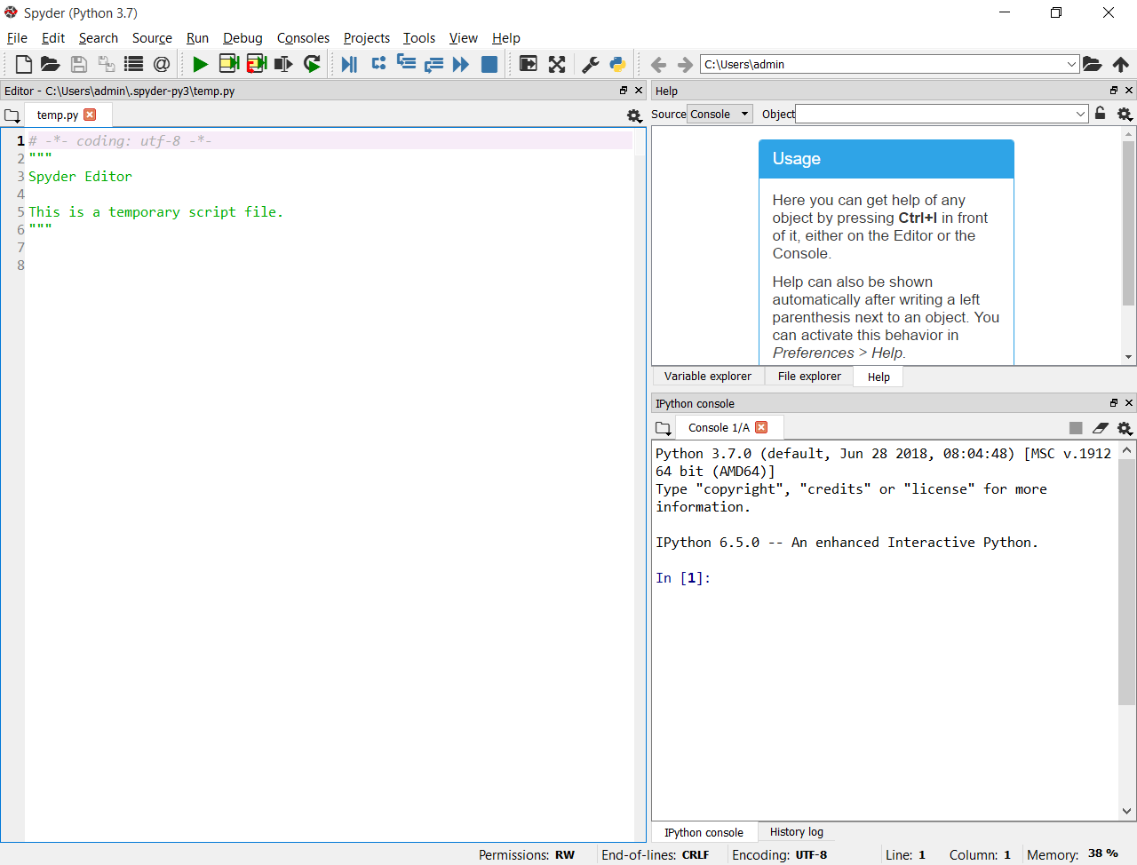
Fig 4: Code Window of Spyder
- Pycharm
PyCharm is an integrated development environment (IDE) used in computer programming, specifically for the Python language. It is developed by the Czech company JetBrains. It provides code analysis, a graphical debugger, an integrated unit tester, integration with version control systems (VCSes), and supports web development with Django as well as Data Science with Anaconda.

Fig 5: Pycharm Logo
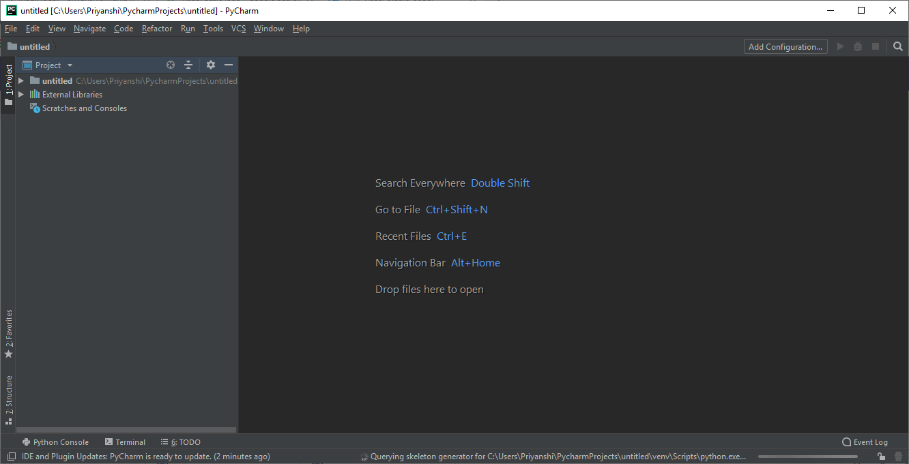
Fig 6: Code Window of Pycharm

- Visual Code Studio
Visual Studio Code combines the simplicity of a source code editor with powerful developer tooling, like IntelliSense code completion and debugging.
First and foremost, it is an editor that gets out of your way. The delightfully frictionless edit-build-debug cycle means less time fiddling with your environment, and more time executing on your ideas.
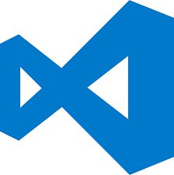
Fig 7: Visual Code Studio Logo

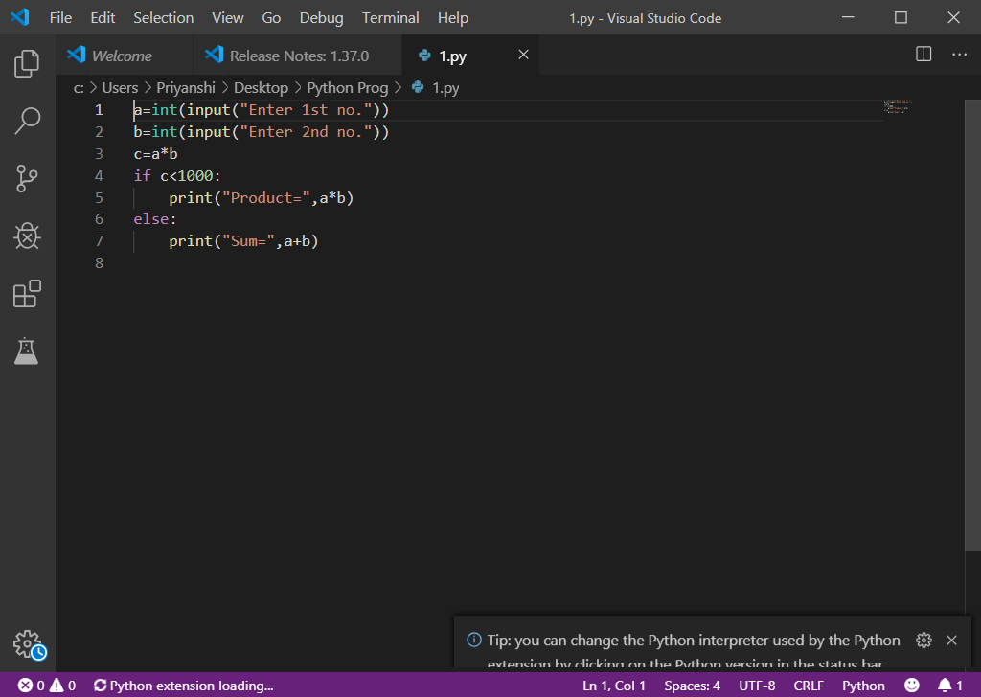
Fig 8: Code Window of Visual Code Studio

